Developer Environment Setup Documentation

 1. Operating System Installation

Steps and Screenshots of Windows 11 Installation:

1. Download Windows 11:

   - Visit the official Microsoft website: [Windows 11 Download](https://www.microsoft.com/software-download/windows11).

   - Download the Windows 11 Installation Assistant.

   - Run the downloaded file and follow the on-screen instructions to upgrade or install Windows 11.

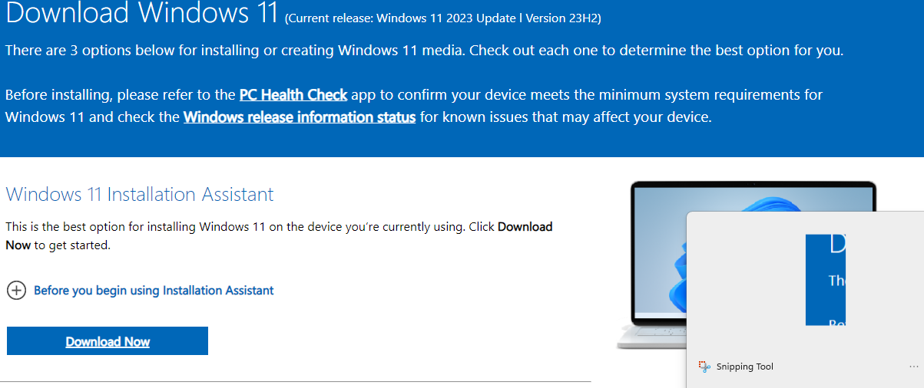

2. Installation Process:

   - Ensure your PC meets the minimum system requirements.

   - Back up your important files.

   - Follow the installation steps, including selecting the installation type, partitioning your hard drive if necessary, and configuring initial settings.

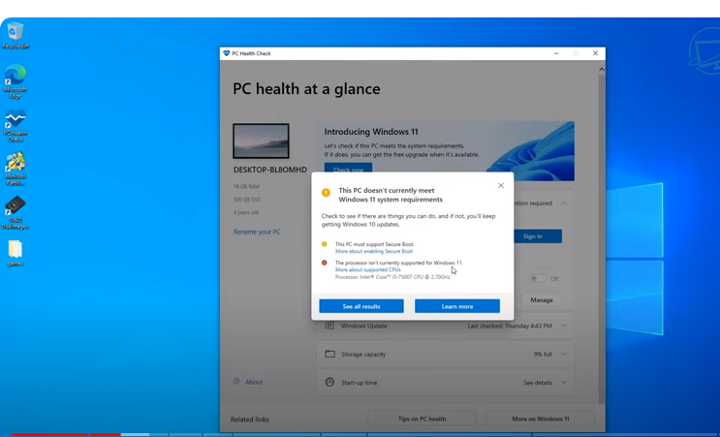

3. Post-Installation Setup:

   - Configure your user account, regional settings, and privacy settings.

   - Install necessary drivers and updates.

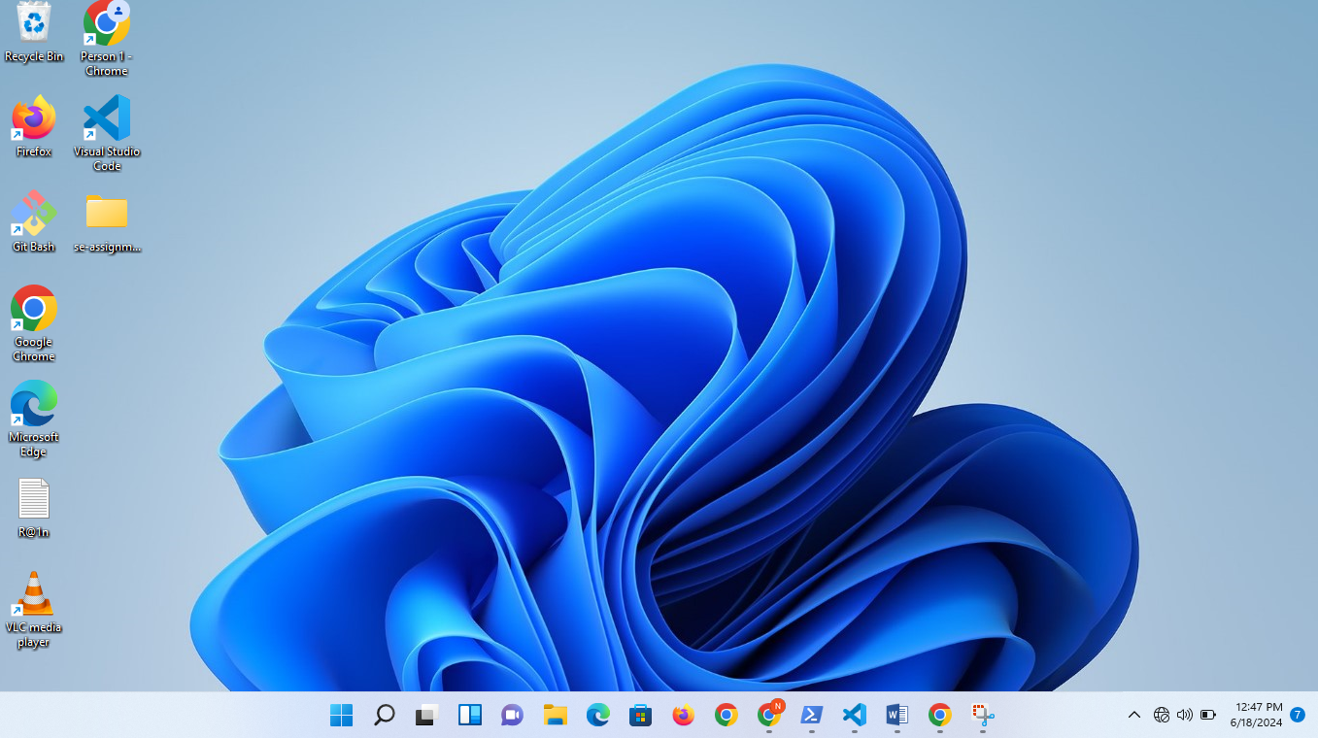

2. IDE Installation

Steps and Screenshots of Visual Studio Code Installation:

1. Download VS Code:

   - Visit the Visual Studio Code download page: [VS Code Download](https://code.visualstudio.com/Download).

   - Select the appropriate version for Windows and download the installer.

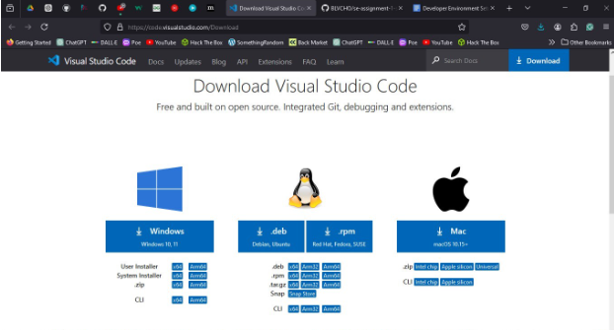

2. Installation Process:

   - Run the downloaded installer.

   - Follow the installation wizard, accepting the license agreement and choosing the installation location.

   - Select additional tasks such as adding to PATH and creating a desktop icon.

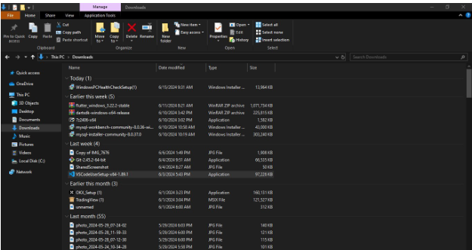

3. First Launch and Setup:

   - Launch VS Code and install recommended extensions like Python, GitLens, and Docker.code runner

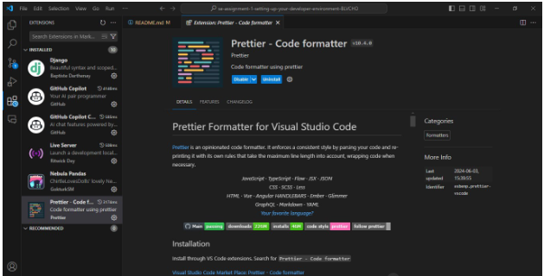

3. Version Control Setup

Steps for Installing Git, Creating a GitHub Account, Initializing a Repository, and Making the First Commit:

1. Install Git:

   - Download Git from the official site: [Git Download](https://git-scm.com/downloads).

   - Run the installer and follow the setup instructions, choosing your preferred options for PATH, line endings, and other settings.

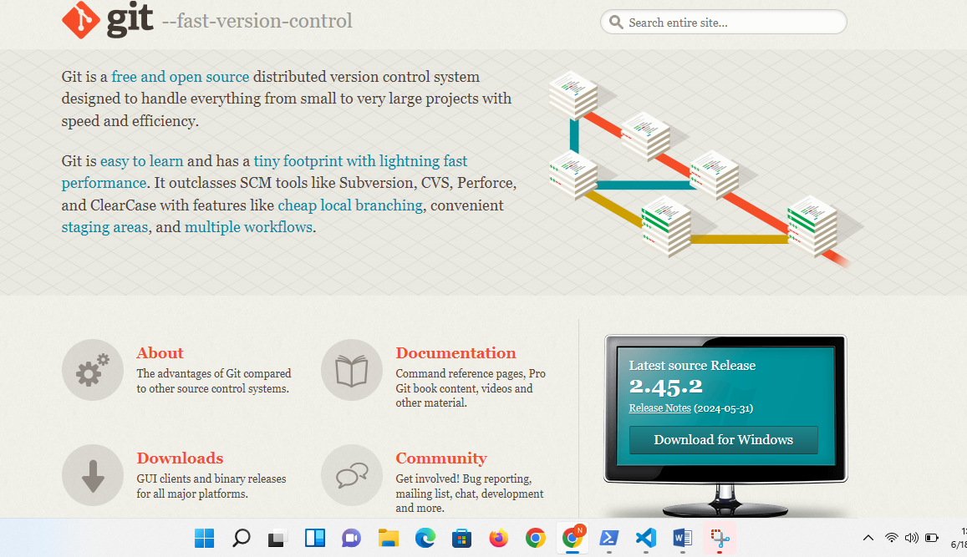

2. Create a GitHub Account:

   - Visit [GitHub](https://github.com) and sign up for a new account if you still need to get one.

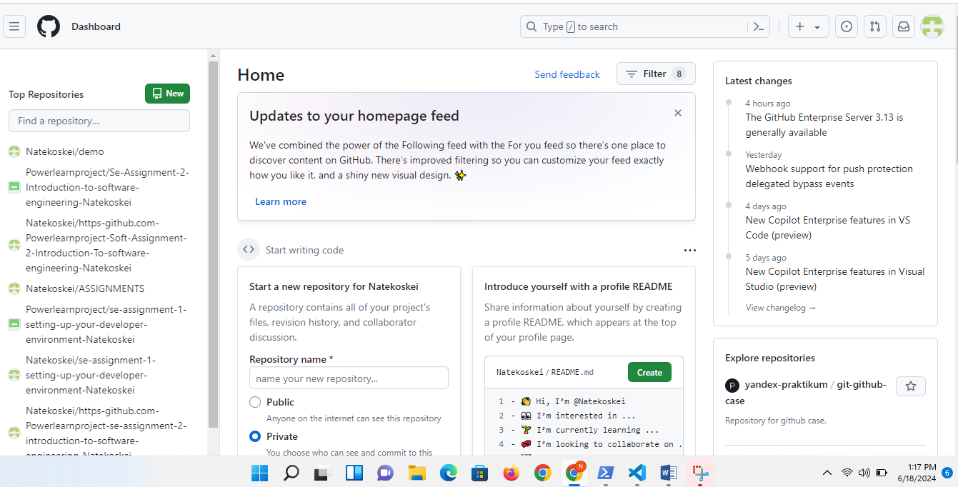

3. Initialize a Git Repository:

   - Open Git Bash or the terminal in VS Code.

   - Navigate to your project directory or create a new one:

  ```bash

  mkdir my_project

  cd my_project

  ```

   - Initialize a Git repository:

  ```bash

  git init

  ```

   - Create a README file:

  ```bash

  echo "# My Project" >> README.md

  ```

   - Add the README file to the staging area:

  ```bash

  git add README.md

  ```

   - Commit the changes:

  ```bash

  git commit -m "Initial commit"

  ```

4. Programming Languages and Runtimes

Steps for Installing Python:

1. Download Python:

   - Visit the official Python website: [Python Download](https://www.python.org/downloads/).

   - Download the latest version of Python for Windows.

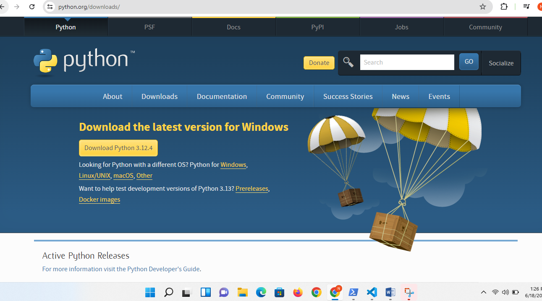

2. Installation Process:

   - Run the installer, ensure you check the option to add Python to PATH.

   - Follow the installation wizard.

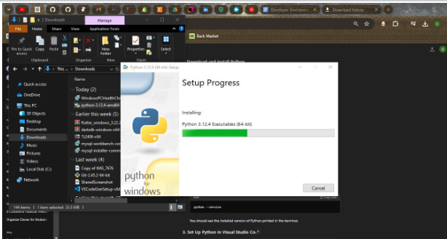

3. Verify Installation:

   - Open Command Prompt and type:

  ```bash

  python --version

  ```

   - Verify pip installation:

  ```bash

  pip --version

5. Package Managers

Verification of pip Installation:

1. Verify pip:

   - Open Command Prompt and type:

  ```bash

  pip –version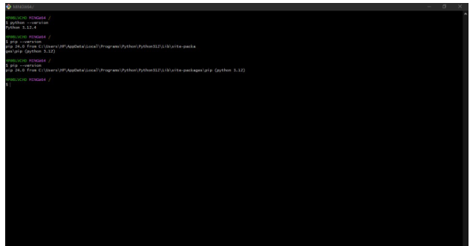

  ```

6. Database Configuration

Steps for Installing MySQL:

1. Download MySQL:

   - Visit the MySQL download page: [MySQL Download](https://dev.mysql.com/downloads/windows/installer/5.7.html).

   - Download the MySQL Installer for Windows.

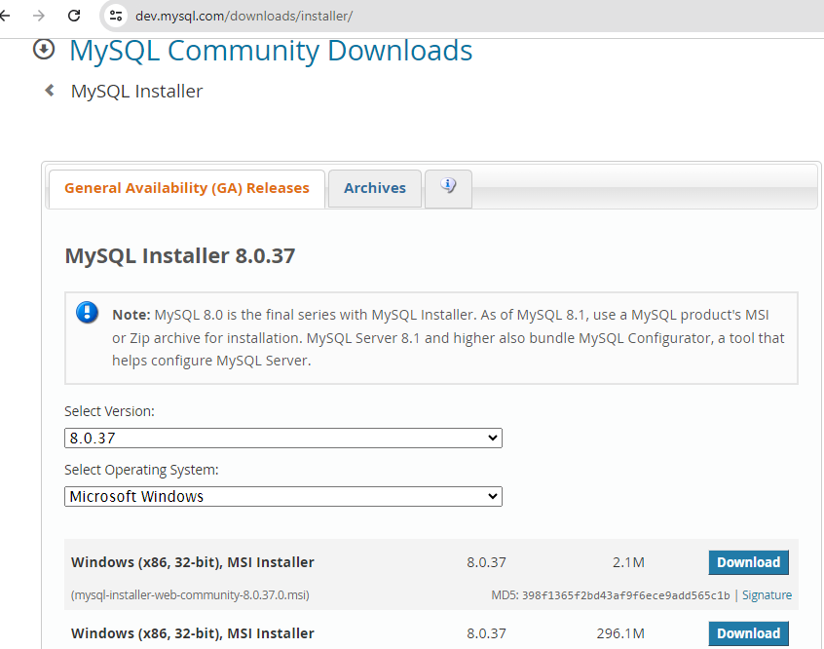

2. Installation Process:

   - Run the MySQL Installer and follow the setup wizard.

   - Choose the setup type (e.g., Developer Default).

   - Configure MySQL Server settings, including the root password.

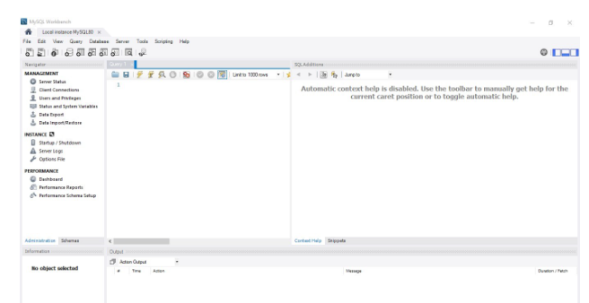

   NB: MYSQL IS ALREADY CONFIGURED WITH PASSWORD

3. Verify Installation:

   - Open MySQL Workbench or MySQL Shell and connect to your MySQL server.

7. Development Environments and Virtualization (Optional)

Optional Steps for Installing and Setting Up Docker:

1. Download Docker:

   - Visit the Docker Desktop download page: [Docker Download](https://www.docker.com/products/docker-desktop).

   - Download and run the Docker Desktop installer.

   ![Docker Download](images/docker-download.png)

2. Installation Process:

   - Follow the installation instructions.

   - Start Docker Desktop and follow the setup wizard.

3. Verify Installation:

   - Open Command Prompt or PowerShell and type:

  ```bash

  docker --version

  ```

8. Extensions and Plugins

List of Installed Extensions for VS Code:

1. Install Extensions:

   - Open VS Code.

   - Go to the Extensions view (`Ctrl+Shift+X`).

   - Search for and install the following extensions:

  - Python

  - GitLens — Git supercharged

  - Docker

  - Prettier - Code formatter

  - ESLint

  - MySQL

-Dart

-Flutter

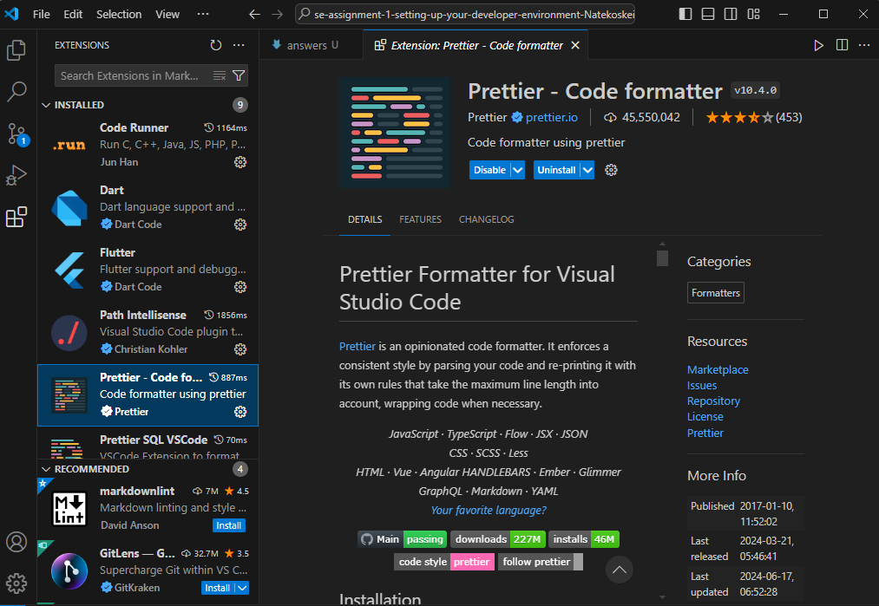

9. Challenges and Solutions

1. Challenge: Installing MySQL and Configuring the Root Password

   - Solution: Followed a step-by-step tutorial and used the official MySQL documentation for troubleshooting.

2. Challenge: Initializing a Git Repository and Making the First Commit

   - Solution: Used Git documentation and GitHub guides to understand the commands and workflow.

Deliverables

1. Setup Documentation:

   - This document with detailed steps and screenshots.

2. GitHub Repository:<https://github.com/BLVCHO/sample-repository.git>

3. Reflection:

   - Included in the Challenges and Solutions section.